EXPERIMENT : 1

NAME : KRISHNAKUMAR.R ROLL NO : 240701275

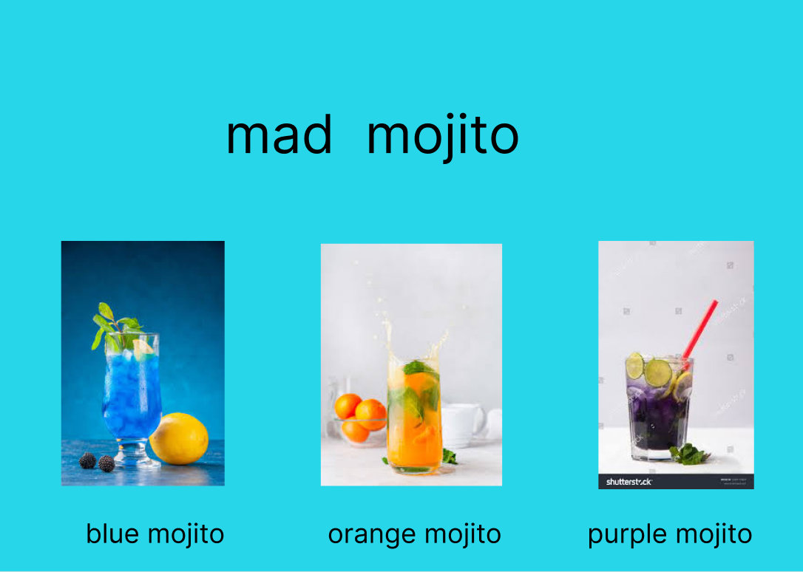

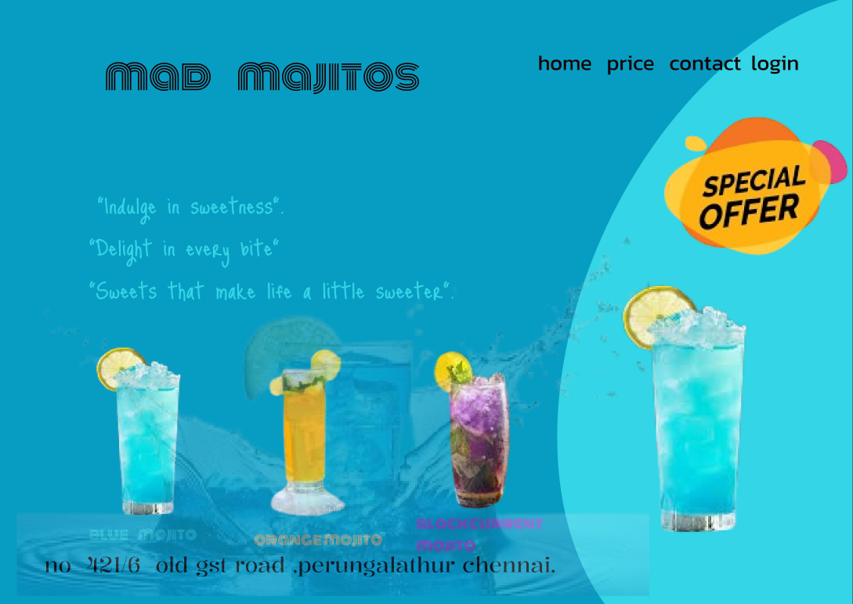

Experiment: Mad Mojito Website Design

Aim
To design and develop a simple Mad Mojito website page using HTML and CSS to display different mojito drinks with images and navigation options.

Objective
- To create a simple drink menu webpage.
- To learn webpage layout design using HTML and CSS.
- To display different mojito flavors with images and names.
Tools / Technologies Used
- HTML – for creating the structure of the webpage
- CSS – for styling the webpage
- Images – for displaying mojito drinks
- Web Browser – to run and view the webpage
Procedure
- Create an HTML file to build the structure of the webpage.
- Add a navigation bar with options such as Home, Price, Contact, and Login.
- Insert a website title “Mad Mojitos” at the top of the page.
- Use CSS styling to set the background color and fonts.
- Add images of different mojito drinks such as:
  - Blue Mojito
  - Orange Mojito
  - Purple Mojito
- Arrange the images in a horizontal layout.
- Add captions under each image to display the drink names.
- Include a special offer section and a short promotional text.
- Add the shop address at the bottom of the page.
- Open the file in a web browser to view the webpage.

Result
A simple Mad Mojito website page was successfully created that displays different mojito drinks, navigation menu, promotional content, and shop details.

Conclusion
This experiment helped to understand the basics of webpage creation using HTML and CSS, including layout design, image placement, and webpage styling.

LINK:
https://www.figma.com/design/OJ3S7vgexATEqzTm5Mkvnf/Untitled?node-id=0-1&t=2cNOekUFy3Ds85JZ-1

